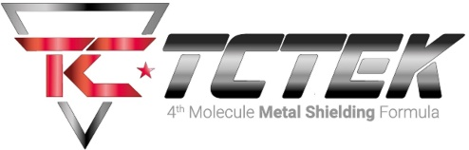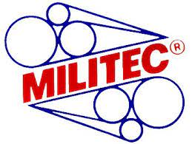

(TCTEK) Militec-1 Synthetic Metal Conditioner
The ultimate Weapons Lubricant and Gun Oil

- Dry and constant lubrıcatıon
- Prevents jamming
- Minimal material buıld-up
- İnhibits corrosion
- Long lasting
- Hıghly concentrated
- Easier cleaning

National Stock Numbers (NSN)

MİLİTEC 5 oz - 9150-01-415-9111
MİLİTEC 1 oz - 9150-01-415-9112
MİLİTEC 4 oz - 9150-01-415-9114
MİLİTEC 8 oz - 9150-01-378-3058
MİLİTEC 16 oz -9150-01-378-3118
