MILITEC-1 Metal Surface Testing
We have received computer printouts from the Materials Science laboratory of the University of Florida showing the results of a comparison of metal surfaces with and without MILITEC-1 treatment. The text below is an attempt to describe the results in terms that less technical people can understand while more technical people can appreciate.
TESTING STIFFNES
Modulus Mapping show the ratio of stress to strain. The testing was performed using Atomic Force Microscopy (also known as Scanning Probe Microscopy) with a Topometrix Model TMX 2000. The metal surface was on case-hardened, carbonised S620steel, tapered rollers (used in wheel bearings) with a Rockwell hardness on the C scale of 58-63. To treat the metal, a film of MILITEC-1 was applied and the roller was heated at 104C for 50 minutes. The metal was allowed to cool to ambient temperature and remaining MILITEC-1 oil was wiped off.

UNTREATED SURFACE MİLİTEC-1 TREATED SURFACE
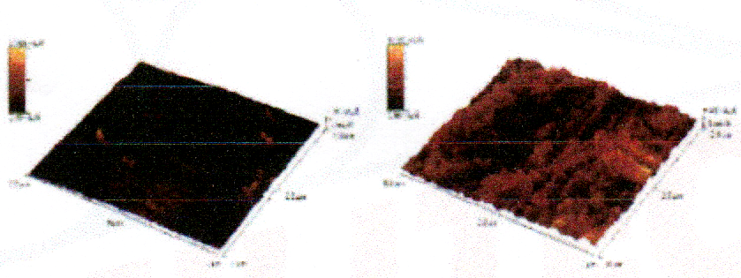

The two graphic illustrations show the stiffness of the metal surface (not the hardness of the metal). The colour range of each illustration show the range of stiffness for that sample. The lighter the surface, the higher the stiffness relative to the lowest stiffness recorded for that sample. The lowest recorded stiffness of the MILITEC-1 treated meta surface is 16.8 times greater than the lowest recorded stiffness of the untreated metal surface. Much of the surface of the treated metal shows a stiffness in the upper level of the range of that sample Almost all of the surface of the untreated metal shows a stiffness in the lower level of the range of that sample. This comparison indicates a very significant increase in stiffness due to the MILITEC-1 treatment.
Atomic Force Microscopy uses an extremely thin needle (400 angstroms in diameter = .04 micron) which is pressed against the surface of the metal. For every unit of force (measured on the diagram as Nano amps) exerted down onto the metal surface, the surface will be deformed a certain amount (angstroms). The graphic illustrations show that to achieve the same amount of deformation, the needle must be pressed against the surface with different amount of force depending on the stiffness of the surface at that point of contact. The peaks show where more force needed to be applied to counter the stiffness. The MILITEC-1 treated surface clearly shows the greater level of stiffness.
TOPOGRAPHY
Atomic Force Microscopy also can map the topography of the metal surface by measuring vertical change as the needle is moved along the metal surface. The untreated metal surface, as seen in the graphic illustration, appears very even. The steady evolution from yellow to dark brown depicts the round shape of the roller. The needle must climb to move over the rounded surface so the colour is not uniform. The topography of the MILITEC-1 treated metal surface has ridges which show that the surface is not even. The MILITEC-1 has not bonded uniformly but its presence is clearly seen.

UNTREATED SURFACE MİLİTEC-1 TREATED SURFACE
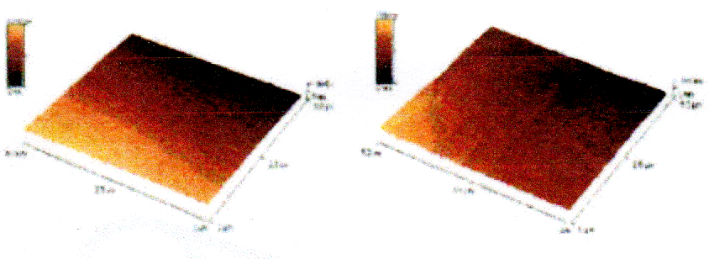
It is important to note that the metal samples depicted in the graphic illustrations are only 5 microns square which is an extremely small part of the overall surface of the roller. The areas scanned in the depicted samples were seen in preliminary microscopy examination over random areas of the metal to be typical of the surface of the rollers.
INFRARED SPECTROSCOPY
This test used the same metal surfaces that were tested with Atomic Force Microscopy, but here the treated and untreated surfaces were examined across the spectrum to see what chemicals were present on the metal surfaces. The metal surface treated with MILITEC-1 had received the treatment many months before this test and the metal had been exposed to the atmosphere throughout this period. Even during the test, the metal was exposed to the atmosphere in the laboratory. The most telling part of the test result is in the wavelength area between 1300 and 1900 and equally between 3500 and 4000. The jagged lines represent the presence of water. The top line and the bottom two lines are untreated surfaces while the other two are treated. The two lines for the treated metal show very minimal presence of water. The MILITEC-1 has affected the metal surface so that water is not readily attracted (typical bare metal attracts water which can lead to rust). This test result helps to explain the ability of MILITEC-1 to reduce rust and corrosion. The double dip in the centre of the graph is CO2.

This test was performed using an IR Nicolet Magna IR Spectrometer model 750.
